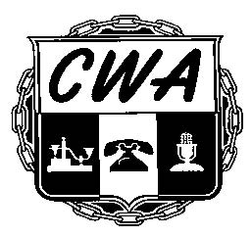***Communication Workers of America*** *AFL-CIO* ***Local 1150***

6 Harrison Street 4th Floor, New York, NY 10013-2883 [Unity1150@aol.com](mailto:Unity1150@aol.com) (212) 925-6650 Fax (212) 925-5737

Vincent A. Whitley William Naveira Yvonne Pacheco

President Vice President Secretary-Treasurer

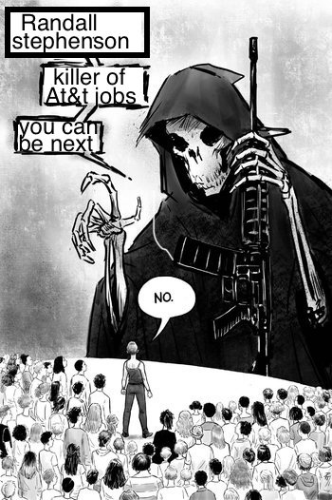

<https://www.goodjobsatt.org/>

