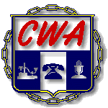
Communication Workers of America AFL-CIO Local 1150
25 Broadway 9th Floor, New York, NY 10004 Unity1150@aol.com (212) 925-6650 Fax (212) 925-5737

Vincent A. Whitley William Naveira Yvonne Pacheco
President Vice President Secretary-Treasurer

Date:

We, the undersigned, mutually agree to waive the time limits for the Grievance number(s) ________________.

Print Name: ____________________________ Print Name: __________________________
(CWA Local 1150 Representative) (AT&T Representative)

______________________________ _________________________________
(Title) (Title)

______________________________ _________________________________
(Telephone Number) (Telephone Number)

_______________________________ __________________________________
(Signature) (Signature)

