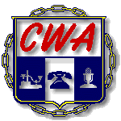
Communication Workers of America AFL-CIO Local 1150
25 Broadway 9th Floor, New York, NY 10004 Unity1150@aol.com (212) 925-6650 Fax (212) 925-5737

Vincent A. Whitley William Naveira Yvonne Pacheco
President Vice President Secretary-Treasurer

Date: _____________

Representatives ___________________ for AT&T and ____________________ for CWA Local 1150 hereby agree

to waive step 1 of the grievance procedure on grievance number(s) ________________.

Signatures:

___________________AT&T

___________________CWA Local 1150

